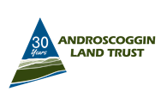
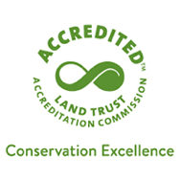
Androscoggin Land Trust
Land Use Permission

I would like permission to use your property to:
___ ATV ___ Fish ___Hunt ___Snowmobile ___Trap ___Other
___________________________________________________________
Property Name ___________________________________________
City____________________________________________________
I give permission to:

Land User’s Name_____________________________________________

Address______________________________________________________

City_______________________________State______________________

Phone________________________Vehicle License#_________________

Machine Reg#___________________Make/Model___________________

Permission granted from ________________ to _________________ (date)

Landowners Signature__________________________________________
Rules for Use: Just a few rules for a safe hunt:
1.You must follow all state and local laws.
2.If you are found to be in violation of hunting laws (baiting, poaching, driving deer, etc.) your permission will be revoked.
3.Carry in carry out. Please do not litter.
4. The use of game cameras by permission. May not be used on or near hiking trails.
5. Portable climbing hunting stands and blinds can be used but must be removed at the end of your hunt. Any left behind will become property of ALT.
6. Motorized vehicles are not allowed outside designated areas.
7. See something say something. We work with the Maine Warden service supporting fair hunting practices.
Good luck and enjoy your hunt. We love to hear from you send us photos or let us know about your adventure.
